Instructions for using the ADO Connection Coder Ver 1.00
By John Attfield 07/06/2004 11:27

Objective
This little utility allows the user to select an Access database and then generates the code
to make a connection. It also allows the user to select a table from the database which then
generates a simple SQL.

If there is sufficient interest I will continue to develop code-writing programs and submit them to PlanetSourceCode.

To test the ADO Connection Coder you need to create a small standard project and add:

- A Form.
- A Datagrid Control.
(Via Project menu – Components – Microsoft DataGrid Control 6.0 (OLEDB)
- A Command Button. (Name as Connect)

Add references to:

- Microsoft ADO.ext for DLL and Security
- Microsoft ActiveX Data Objects 2.5 Library or later
(Via Project menu – References)

Data Grid

Right Click on the datagrid and select Properties.

Select the Columns Tab
In column(0) Caption - enter “Name”
In column(1) DataField - enter “Title”

Click on the “Apply” button then “OK”

When you are using the “ADO Connection Coder” in your own application you would enter the details for each of the columns in your own database. Once you have seen the final result you can change the column widths of the fields. For the Contacts Database setting the column widths to 2000 should be sufficient.

Command Button
In the “Command Button” Click Sub Subroutine that you have named “Connect” insert:
Call “Name of Routine” as generated by “ADO Connection Coder” for example in this case it will be (Call Contacts) the name of the database.

Private Sub Command1_Click()
Call Contacts
End Sub

The resulting form should look something like this
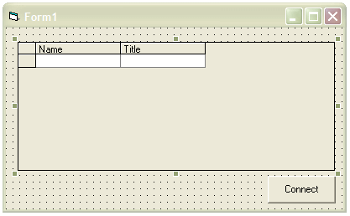

ADO Connection Coder

Load, compile then run the Connection Coder.

In the File menu select “Load Database”

The common dialog Box will display.
Select the drive and subdirectory containing the test project above.
In the directory select the database named “Contacts”

Details of the database will be displayed.
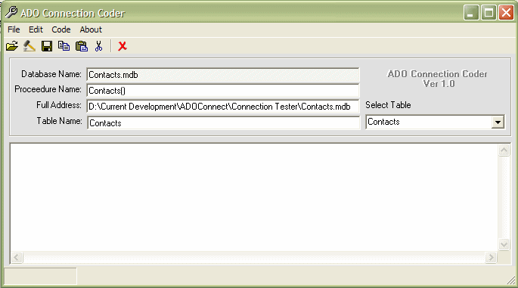

In the “Select Table” ComboBox all the tables in the database will be shown. In the Contacts.mdb there is only one table.

Create Code
To create the code, go to the “Code Menu” and select “Make Code”

The Result should be similar to this.
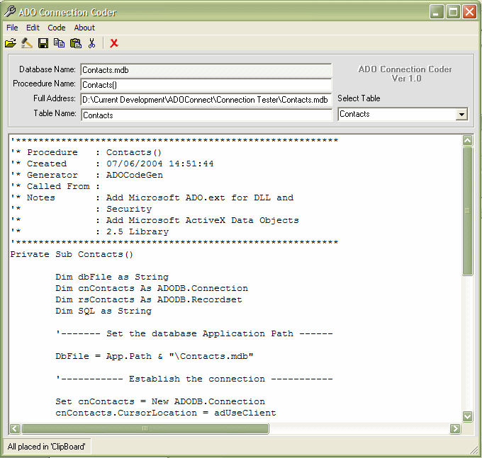

Notice that the procedure has been named after the database name. You can change the name if you wish, then remake.

Cut and Paste

Using the “Cut and Paste commands” you can select the code and paste it into your project.

If you use the right click function of you mouse you must first select the text you wish to transfer however if you select copy from the menu or toolbox and you have not selected any code, all the code will be copied to the “Clip Board”.

Test Project
Having copied the complete routine to your project you have, in fact, created a new SubRoutine, and your project is almost ready to run.

Datagrid1

All that remains is to connect the DataGrid to the recordset. Insert the following code into the area after the remark ‘Carry out functions on the database :

'----- Carry out functions on the database -----

Set DataGrid1.DataSource = rsContacts
DataGrid1.Refresh

'------------ Close the Connection --------------

'------------ Close the Connection --------------

At the end of the code you will notice the following remarks:

'cnContacts.Close
'Set cnContacts = Nothing

Place this in a position in your project when you want to close the connection

That’s it run the test project

Test Project Final Code
Private Sub Command1_Click()
Call Contacts
End Sub
'*********************************************************
'* Procedure : Contacts()
'* Created : 07/06/2004 14:39:19
'* Generator : ADOCodeGen
'* Called From :
'* Notes : Add Microsoft ADO.ext for DLL and
'* : Security
'* : Add Microsoft ActiveX Data Objects
'* : 2.5 Library
'*********************************************************
Private Sub Contacts()

Dim dbFile as String
Dim cnContacts as ADODB.Connection
Dim rsContacts as ADODB.Recordset
Dim SQL as String

'------- Set the database Application Path ------

dbFile = App.Path & "\Contacts.mdb"

'----------- Establish the connection -----------

Set cnContacts = New ADODB.Connection
cnContacts.CursorLocation = adUseClient
cnContacts.ConnectionString = ┐
"Provider=Microsoft.jet.OLEDB.4.0;" & "Data ┐
Source=" & dbFile & ";" & "Persist Security Info=False"

'-------------- Open the connection -------------

cnContacts.Open

'---------- Enter your SQL Statement Here -------

SQL = "SELECT Contacts.* "
SQL = SQL & "FROM Contacts;"

'--------------- Get the Records ----------------

Set rsContacts = New ADODB.Recordset
rsContacts.Open SQL, cnContacts, adOpenStatic, ┐
adLockOptimistic, adCmdText

'----- Carry out functions on the database -----
Set DataGrid1.DataSource = rsContacts
DataGrid1.Refresh

'------------ Close the Connection --------------

'cnContacts.Close
'Set cnContacts = Nothing
End Sub

